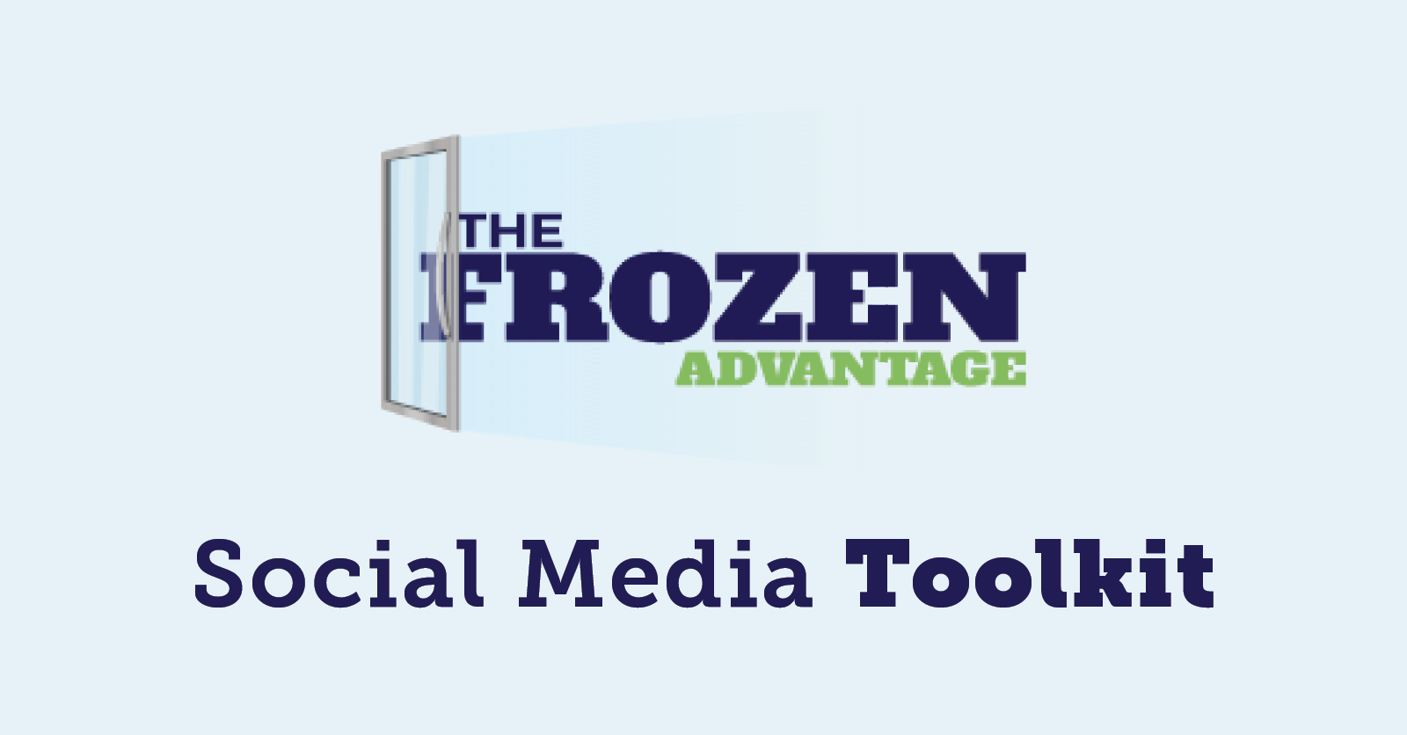

Introduction:
Social media provides a powerful opportunity to share the positive story about the benefits of frozen foods. This toolkit will assist in high quality social media messaging and imagery for Facebook, Twitter and LinkedIn. Join in our efforts to bring awareness and educate users on the #FrozenAdvantage.

Instructions:
To use weekly content for each social channel, copy and paste messaging below into your Facebook, Twitter or LinkedIn feed.

Post each message with our pre-designed social image.

Suggested use:
Post about the benefits of frozen food once a week with our Frozen Advantage toolkit.

Suggested hashtags:
At a minimum, be sure the posts utilize #FrozenAdvantage so we can track our reach. Here are other hashtags for your consideration to support additional visibility:
#FrozenFoods #FoodWasteSolution #FrozenFightsFoodWaste #FrozenFoodFacts

Best times to post for organic reach:
Facebook: Wednesday or Thursday between 11 am - 12 pm
Twitter: Wednesday or Friday between 8 am - 10 am
LinkedIn: Wednesday or Thursday between 8 am - 10 am
NUTRITION

Facebook:
1.) Should you eat more frozen foods?
Studies say yes! According to Nutritionist, Keri Glassman, "It's one of the best health secrets! Frozen vegetables are picked at peak ripeness, when they are most nutritious and then they are flash frozen so they retain those nutrients."
Watch to learn more about the latest nutrition research on frozen ⬇️
https://cnn.it/3flrgHj
2.) MYTH ❌ Frozen meals aren't a good choice for health-conscious consumers
FACT ✅ "Better-for-you" options are available in the frozen food aisle to make it easier for consumers to control intakes of calories, fat, saturated fat and sodium with clear nutritional information and portion-controlled packaging.
Get the frozen facts >> https://bit.ly/3tY8REU

Twitter:
1.) Should you eat more frozen foods?
According to Nutritionist, Keri Glassman, "It's one of the best health secrets! Frozen vegetables are picked at peak ripeness, when they are most nutritious and then they are flash frozen to retain those nutrients."
﻿﻿https://cnn.it/3flrgHj
2.) MYTH ❌ Frozen meals aren't a good choice for health-conscious consumers
FACT ✅ "Better-for-you" options are available in the frozen food aisle to make it easier for consumers to control intakes of calories, fat, saturated fat & sodium
Learn more >> https://bit.ly/3tY8REU

LinkedIn:
1.) Should you eat more frozen foods?
Studies say yes! According to Nutritionist, Keri Glassman, "It's one of the best health secrets! Frozen vegetables are picked at peak ripeness, when they are most nutritious and then they are flash frozen so they retain those nutrients."
Watch to learn more about the latest nutrition research on frozen ⬇️
https://cnn.it/3flrgHj
2.) MYTH ❌ Frozen meals aren't a good choice for health-conscious consumers
FACT ✅ "Better-for-you" options are available in the frozen food aisle to make it easier for consumers to control intakes of calories, fat, saturated fat and sodium with clear nutritional information and portion-controlled packaging.
Get the frozen facts >> https://bit.ly/3tY8REU

VARIETY

Facebook:
1.) Looking to add something new to your meal rotation? Check out the frozen food aisle! Today's frozen food aisle offers a more diverse selection of ingredients, side dishes and entrées than ever before. ﻿See the endless possibilities of frozen >> ﻿ https://bit.ly/3tOwBvS﻿
2.) When the calendar is filled with events, bring enjoyment to any occasion with frozen foods! The frozen food aisle offers multi serve options and appetizers to make entertaining a breeze. See more benefits of buying frozen >> https://bit.ly/3tOwBvS﻿

Twitter:
1.) Looking to add something new to your meal rotation? Check out the frozen food aisle! Today's frozen food aisle offers a more diverse selection of ingredients, side dishes & entrées than ever before. ﻿See the endless possibilities of frozen >> ﻿ https://bit.ly/3tOwBvS﻿

2.) When the calendar is filled with events, bring enjoyment to any occasion with frozen foods! The frozen food aisle offers multi serve options and appetizers to make entertaining a breeze. See more benefits of buying frozen >> https://bit.ly/3tOwBvS﻿

LinkedIn:
1.) Looking to add something new to your meal rotation? Check out the frozen food aisle! Today's frozen food aisle offers a more diverse selection of ingredients, side dishes and entrées than ever before. ﻿See the endless possibilities of frozen >> ﻿ https://bit.ly/3tOwBvS﻿
2.) When the calendar is filled with events, bring enjoyment to any occasion with frozen foods! The frozen food aisle offers multi serve options and appetizers to make entertaining a breeze. See more benefits of buying frozen >> https://bit.ly/3tOwBvS﻿

SUSTAINABILITY

Facebook:
1.) Did you know? 💡
Forty percent of all food in the United States goes uneaten, an amount equivalent to $165 billion annually. Help fight food waste when you buy frozen foods! Watch to learn how frozen foods are the ideal food waste solution. https://bit.ly/3vxxedT
2.) Help save the planet by reducing food waste 🌎
Did you know we throw out 25% of the food we bring home? Buying frozen food generates 47% less waste when compared to fresh and refrigerated foods. Here's why frozen food is the solution to the food waste problem ⬇️
✅ Keep meals, fruits & veggies on hand year round
✅ Easily prepare when you need & store the rest for later
✅ Tasty meals are ready when you are
✅ 70% of frozen foods packaging is completely recyclable
Learn more about frozen food sustainability >> https://bit.ly/370VXNe
3.) FACT: 89% of Americans think food waste is a concern and many families cannot afford to let food spoil. Here are 3 easy things you can do to be a part of the food waste solution:
1. Buy frozen foods that can be ready when you are and don’t go to waste
2. Freeze leftovers and eat them when it’s convenient for you
3. Freeze meals and ingredients in advance to enjoy later
Learn more about fighting food waste >> https://bit.ly/370VXNe

Twitter:
1.) Did you know? 💡
Forty percent of all food in the United States goes uneaten, an amount equivalent to $165 billion annually. Help fight food waste when you buy frozen foods! Watch to learn how frozen foods are the ideal food waste solution. https://bit.ly/3vxxedT
2.) Americans throw out 25% of the food we bring home. Buying frozen food generates 47% less waste when compared to fresh and refrigerated foods. Learn why frozen food is the solution to the food waste problem >> https://bit.ly/370VXNe

3.) FACT: 89% of Americans think food waste is a concern & many families cannot afford to let food spoil. Here’s what you can do to be a part of the food waste solution:
1. Buy frozen foods
2. Freeze leftovers
3. Freeze meals & ingredients in advance
Learn more >> https://bit.ly/370VXNe

LinkedIn:
1.) Did you know? 💡
Forty percent of all food in the United States goes uneaten, an amount equivalent to $165 billion annually. Help fight food waste when you buy frozen foods! Watch to learn how frozen foods are the ideal food waste solution.
https://bit.ly/3vxxedT

2.) Help save the planet by reducing food waste 🌎
Did you know we throw out 25% of the food we bring home? Buying frozen food generates 47% less waste when compared to fresh and refrigerated foods. Here's why frozen food is the solution to the food waste problem ⬇️
✅ Keep meals, fruits & veggies on hand year round
✅ Easily prepare when you need & store the rest for later
✅ Tasty meals are ready when you are
✅ 70% of frozen foods packaging is completely recyclable
Learn more about frozen food sustainability >> https://bit.ly/370VXNe
3.) FACT: 89% of Americans think food waste is a concern and many families cannot afford to let food spoil. Here are 3 easy things you can do to be a part of the food waste solution:
1. Buy frozen foods that can be ready when you are and don’t go to waste
2. Freeze leftovers and eat them when it’s convenient for you
3. Freeze meals and ingredients in advance to enjoy later
Learn more about fighting food waste >> https://bit.ly/370VXNe

FARM TO FREEZER

Facebook:
1.) Let’s talk fresh vs. frozen! Frozen fruits and vegetables are picked at peak ripeness, providing the same nutrients as fresh produce - sometimes more! Frozen foods also last longer, are more affordable than fresh and increase access to fruits and vegetables in every community during all seasons.
Learn about the journey from farm to freezer >> https://bit.ly/3d3VDB6
2.) Freezing is nature's pause button ⏸️
Freezing simply pauses just-picked, just-baked and just-crafted foods - keeping them at their peak of freshness and locking in their flavor and nutrients.
Learn more about the path to frozen >> https://bit.ly/3d3VDB6

Twitter:
1.) Let’s talk fresh vs. frozen! Frozen fruits and vegetables are picked at peak ripeness, providing the same nutrients as fresh produce! Frozen foods also last longer, are more affordable than fresh and increase access to fruits and vegetables.
Learn more >> https://bit.ly/3d3VDB6

2.) Freezing is nature's pause button ⏸
Freezing simply pauses just-picked, just-baked and just-crafted foods - keeping them at their peak of freshness and locking in their flavor and nutrients.
Learn more about the path to frozen >> https://bit.ly/3d3VDB6

LinkedIn:
1.) Let’s talk fresh vs. frozen! Frozen fruits and vegetables are picked at peak ripeness, providing the same nutrients as fresh produce - sometimes more! Frozen foods also last longer, are more affordable than fresh and increase access to fruits and vegetables in every community during all seasons.
Learn about the journey from farm to freezer >> https://bit.ly/3d3VDB6
2.) Freezing is nature's pause button ⏸️
Freezing simply pauses just-picked, just-baked and just-crafted foods - keeping them at their peak of freshness and locking in their flavor and nutrients.
Learn more about the path to frozen >> https://bit.ly/3d3VDB6

OTHER BENEFITS

Facebook:

1.) Why you should put frozen foods first ⬇️
✔️ Nutritious
✔️ Variety of choices
✔️ Easy to prepare
✔️ Helps reduce food waste
✔️ Affordable
Frozen foods fit every family's lifestyle without compromising nutrition or taste while providing a diverse selection of ingredients, side dishes and entrées than ever before.
Learn more about the frozen advantage >> https://bit.ly/3fevWPz

2.) Frozen foods are good for you and your wallet! Realistic, balanced and affordable menus featuring mostly frozen foods can meet energy, nutrient and cost goals based on recommendations from the Dietary Guidelines for Americans, MyPlate and USDA’s Moderate Cost Food Plan.
Learn how to achieve dietary guidelines with frozen food >> https://bit.ly/3ffk3Z7

3.) 6 ways frozen foods make mealtime easier ⬇️
1. Speed up meal prep
2. Get necessary nutrients
3. Simplify cooking
4. Cut food waste
5. Manage serving sizes
6. Save time meal planning
Learn more about reducing mealtime stress >> https://bit.ly/3tRpliH

4.) Not only is frozen food good for you, it's good for the economy! Frozen food and beverage companies boost U.S. food sales, tax revenue and jobs nationwide ⬇️
Learn more about the impact >> ﻿https://bit.ly/3qeGHD3

Twitter:

1.) Why you should put frozen foods first ⬇
✔️ Nutritious
✔️ Variety of choices
✔️ Easy to prepare
✔️ Helps reduce food waste
✔️ Affordable
Frozen foods fit every family's lifestyle without compromising nutrition or taste!
Learn more >> https://bit.ly/3fevWPz

2.) Frozen foods are good for you and your wallet! Realistic, balanced and affordable menus featuring mostly frozen foods can meet energy, nutrient and cost goals based on recommendations from the Dietary Guidelines for Americans.
Learn more >> https://bit.ly/3ffk3Z7

3.) 6 ways frozen foods make mealtime easier ⬇️
1. Speed up meal prep
2. Get necessary nutrients
3. Simplify cooking
4. Cut food waste
5. Manage serving sizes
6. Save time meal planning
Learn more about reducing mealtime stress >> https://bit.ly/3tRpliH

4.) Not only is frozen food good for you, it's good for the economy! Frozen food and beverage companies boost U.S. food sales, tax revenue and jobs nationwide ⬇️
Learn more about the impact >> ﻿https://bit.ly/3qeGHD3

LinkedIn:
1.) Why you should put frozen foods first ⬇️
✔️ Nutritious
✔️ Variety of choices
✔️ Easy to prepare
✔️ Helps reduce food waste
✔️ Affordable
Frozen foods fit every family's lifestyle without compromising nutrition or taste while providing a diverse selection of ingredients, side dishes and entrées than ever before.
Learn more about the frozen advantage >> https://bit.ly/3fevWPz

2.) Frozen foods are good for you and your wallet! Realistic, balanced and affordable menus featuring mostly frozen foods can meet energy, nutrient and cost goals based on recommendations from the Dietary Guidelines for Americans, MyPlate and USDA’s Moderate Cost Food Plan.
Learn how to achieve dietary guidelines with frozen food >> https://bit.ly/3ffk3Z7

3.) 6 ways frozen foods make mealtime easier ⬇️
1. Speed up meal prep
2. Get necessary nutrients
3. Simplify cooking
4. Cut food waste
5. Manage serving sizes
6. Save time meal planning
Learn more about reducing mealtime stress >> https://bit.ly/3tRpliH

4.) Not only is frozen food good for you, it's good for the economy! Frozen food and beverage companies boost U.S. food sales, tax revenue and jobs nationwide ⬇️
Learn more about the impact >> ﻿https://bit.ly/3qeGHD3

